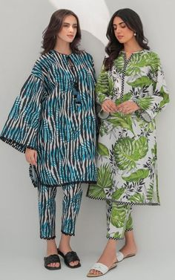

**Gul ahmed lawn**

Gul Ahmed is known for the best variety of traditional clothing. It was founded in 1998 and manufactures premium clothes with a redefined sense of handloom craft. Although the brand was initiated as a small-scale business in Karachi, it has quickly gained popularity and fame due to its addition of ancient crafting in making clothes. Today it boasts numerous stores within the country.